**Welcome to the Summer 2019 Newsletter.**



Becoming unwell at University happens to almost anyone. However, being away from home, family and friends can make it seem much more difficult. But there is no need to worry as there are a range of places you can turn to for help.

If you become unwell and need to see a doctor you should visit a GP surgery.

Doctors deal with a wide range of health problems, as well as providing health education, offering advice on smoking and contraception, giving vaccinations and carrying out simple surgical operations. You should register with a GP close to where you are living within the first few weeks of moving to University.

Some students have difficulty finding the time to call their surgery during opening hours. Some may also have difficulty getting through to speak to someone if their surgery is very busy. It is important that when you register at a GP surgery that

you also sign up for GP online services.

Have you had your MMR and Meningitis ACWY vaccinations?

Don’t forget to book an appointment with our nurse if your immunisations

are not up to date

By managing your health as part of your overall wellbeing, you can reach your full potential and have a happier time at University.

<http://bit.ly/CareforStudents>

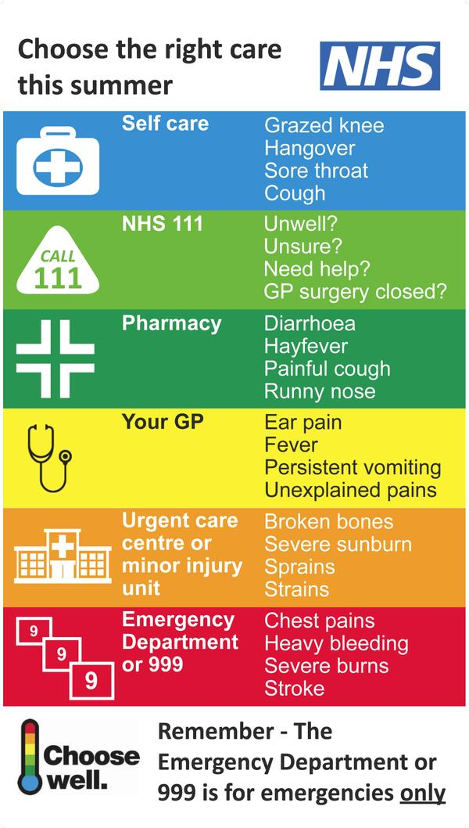



**Have you moved?**

If you have moved recently, we need to know your new address. Please contact the reception team to let them know or update your details using your Online Services Access.

<http://umcbath.co.uk/register-for-online-services/>

**Patient Participation Group**

In order to support the ongoing improvements of our services, we have in place a virtual Patient Participation group. Members of this group may be contacted by the Practice on occasion to ask for their feedback in relation to our services. Our Patient Participation group was established in 2011 and all patients registered with the University Medical Centre are welcome to join at any time.

If you would like to be involved, please contact us and we will send you the application form. Any views you give will be anonymised and this will have no effect on your medical treatment.

<http://umcbath.co.uk/practice-info/patient-participation-group/>

**What do online services mean for you?**

* It’s quick, easy and secure and enables you to do more online
* Repeat prescriptions can be ordered outside of normal working hours, 24/7
* Having access to your GP record means you can check your own immunisations for holidays or studying abroad
* You can check your test results at any time with no need to call the practice
* It will give you more control over your own health care
* You can book appointments even when we are closed
* You can cancel your appointment if it is no longer needed
* You do not have to wait for us to answer the phone



**Health Awareness Calendar**

Did you know that there are many health related National Days?

Here are just a few that you may be interested in for August onwards – just click on the link for further information

**August**

National Immunisation Month <https://www.cdc.gov/vaccines/events/niam/index.html?CDC_AA_refVal=https%3A%2F%2Fwww.cdc.gov%2Fvaccines%2Fevents%2Fniam.html>

Psoriasis Awareness Month <https://www.psoriasis-association.org.uk/>

**September**

Blood Cancer Awareness Month

<https://bloodwise.org.uk/fundraising/campaigns/blood-cancer-awareness-month>

Vascular Disease Awareness Month

<https://www.circulationfoundation.org.uk/vascular-disease-awareness-month>

2-8th National Organ Donation Week

<https://www.organdonation.nhs.uk/get-involved/news/save-the-date-organ-donation-week-2019/>

16th – 22nd Sexual Health Week <https://www.fpa.org.uk/sexual-health-week/sexual-health-week-2019>

16th – 22nd National Eczema Week <http://www.eczema.org/news>

28th World Rabies Day <https://rabiesalliance.org/world-rabies-day>

**October**

National ADHD Awareness Month <https://www.adhdawarenessmonth.org/>

Breast Cancer Awareness Month

<https://www.wearitpink.org/about/breast-cancer-awareness-month?gclid=EAIaIQobChMIhZuImeXS4wIVRLDtCh1S0Q3PEAAYASAAEgKMS_D_BwE>

10th World Mental Health Day <https://www.mentalhealth.org.uk/campaigns/world-mental-health-day>

National Cholesterol Month

<https://www.heartuk.org.uk/national-cholesterol-month/national-cholesterol-month>

**Have you, or someone you care for, recently left hospital?**

The Local Government Association (LGA) is reviewing how health and care services in **Bath and North East Somerset** and **Wiltshire** are working together to support people when they leave hospital.

The LGA want to know what is and isn’t working well, so they can support health and care services and commissioners to identify what improvements need to be made in future.

**Do you live in Bath and North East Somerset or Wiltshire? Have you, or the person you care for or support, been an inpatient* and left hospital within the last year?**

**\***This is when you stay in hospital while you are having treatment or recovering.

**Please share your experiences and views**

1. **Fill in our survey by Monday 2 September 2019. The survey is available in paper form at your GP Practice and online:**

[cid:image001.png@01D54D15.6F648BD0](http://bit.ly/LeavingHospital)

1. **Email us at** [**banes.yourvoice@nhs.net**](mailto:banes.yourvoice@nhs.net) **or call 01225 831 861.**
2. **Take part in a group discussion at St Martins Hospital on Monday 23 September 2019.**

If you would be interested in attending, please contact [banes.yourvoice@nhs.net](mailto:banes.yourvoice@nhs.net) or call 01225 831 861 to find out more.

 

**If you have any feedback you wish to share with us, we would be pleased to hear from you. We welcome all feedback as this helps to drive our service forward for our patients**

<http://umcbath.co.uk/contact-us/patient-feedback/>